* **1.**

What are the two island territories of India?

* + A.

Lakshadweep, and Daman & Diu

* + B.

Puducherry, and Daman & Diu

* + C.

Lakshadweep, and Andaman & Nicobar

* + D.

Andaman & Nicobar, and Puducherry

* **2.**

Koh-i-Noor diamond was mined in which state?

* + A.

Uttar Pradesh

* + B.

Andhra Pradesh

* + C.

Himachal Pradesh

* + D.

Arunachal Pradesh

* **3.**

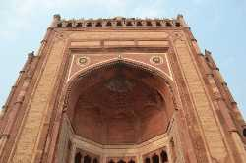

What is the name of this 'victory arch' which serves as one of the entrances to Fatehpur Sikri?

* + A.

Akbar Gate

* + B.

Buland Darwaza

* + C.

Deewan-E-aam

* + D.

Darwaza-E-khaas

* **4.**

Which of these parts of India has the highest battlefield on Earth?

* + A.

Srinagar

* + B.

Shimla

* + C.

Jammu

* + D.

Siachen

* **5.**

What is Pondicherry also called regionally?

* + A.

Puducherry

* + B.

Peducherry

* + C.

Penducherry

* + D.

Puttucherry

* **6.**

In the east of India is One of the popular hill stations of India, famous for its tea plantations. Can you name this town?

* + A.

Kulu-Manali

* + B.

Darjeeling

* + C.

Ooty

* + D.

Kodaikanal

* **7.**

Historical places like Kurukshetra, Panipat, Hisar, Rohtak, and Ambala are some of the towns in which Indian state?

* + A.

Haryana

* + B.

Rajasthan

* + C.

Punjab

* + D.

Uttar Pradesh

* **8.**

What was the first Indian state created on the basis of regional language?

* + A.

Andhra Pradesh

* + B.

Maharashtra

* + C.

Kerala

* + D.

Tamil Nadu

* **9.**

If there is one state in India to single out for its beaches, Goa is the one. Which of the following beaches is in Goa?

* + A.

Candolim beach

* + B.

Besant Nagar Beach

* + C.

Elliott's Beach

* + D.

Dumas Beach

* **10.**

Indira Point and Kanyakumari are both southern extremes of India. Which one of these is located on an island?

* + A.

Indira Point

* + B.

Kanyakumari

* + C.

Both

* + D.

None of these

* **11.**

Chandigarh is a Union Territory:

* + A.

True

* + B.

False

* **12.**

The 'Taj Mahal' was built by how many workers?

* + A.

15000

* + B.

20000

* + C.

30000

* + D.

10000

* **13.**

The largest rice producing state in India is :

* + A.

Andhra Pradesh

* + B.

West Bengal

* + C.

Maharashtra

* + D.

Karnataka

* **14.**

The tallest peak in India and the third tallest in the world is in which Indian state?

* + A.

Sikkim

* + B.

Assam

* + C.

Meghalaya

* + D.

Manipur

* **15.**

People with an interest in which of these fields would be particularly keen to visit the Jantar Mantar

* + A.

Astronomy

* + B.

Astrology

* + C.

Horticulture

* + D.

Zoology

* **16.**

Pick the state that has the following towns and cities: Ernakulam, Kozhikode, Guruvayoor, and Munnar.

* + A.

Tamil Nadu

* + B.

Kerala

* + C.

Karantaka

* + D.

West Bengal

* **17.**

India is the sixth largest country in the world in terms of total land area.

* + A.

True

* + B.

False

* **18.**

One of the following is a famous Soup from India. Which one is it?

* + A.

Mulligatwany

* + B.

Minestrone

* + C.

Borscht

* + D.

Gazpacho

* **19.**

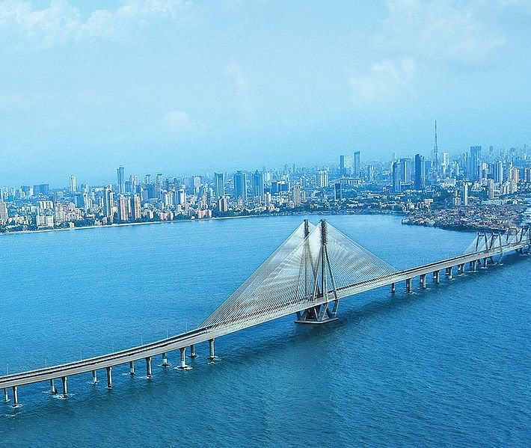

This bridge is in India. True or False?

* + A.

True

* + B.

False

* **20.**

Did you know that Andhra Pradesh has a State Tree? Which is it?

* + A.

Neem

* + B.

Banyan

* + C.

Mango

* + D.

Asoka

* **21.**

The Capital City of Orissa is also popularly known as:

* + A.

Land of Kings

* + B.

Land of Palaces

* + C.

Land of Temples

* + D.

Land of Dreams

* **22.**

India has never hosted the Olympic games.

* + A.

True

* + B.

False

* **23.**

One of the basic questions - How many states and territories does India have?

* + A.

29 states, 6 territories

* + B.

30 states, 7 territories

* + C.

29 states, 7 territories

* + D.

28 states, 6 territories

* **24.**

This brightly colored bird with shades of blue and turquoise is called Indian Roller. This bird is the State bird of which State?

* + A.

Karnataka

* + B.

Andhra Pradesh

* + C.

Himachal Pradesh

* + D.

Uttar Pradesh

* **25.**

The wettest place on earth lies in the state of :

* + A.

Meghalaya

* + B.

Assam

* + C.

Sikkim

* + D.

Arunachal Pradesh

* + 1. Which temple dedicated to the sun-god is shaped like a chariot?  
            
       a) Sun Temple, Konark  
       b) Lotus Temple, New Delhi  
       c) Surya Pahar Temple, Assam  
       d) Jagannath Temple, Puri  
         
       **The correct answer is a) Sun Temple, Konark**  
         
       **2.**This Islamic architecture was built by Shah Jahan as a memorial to his wife. Name it.  
             
       a) Qutub Minar  
       b) Red Fort  
       c) Taj Mahal  
       d) Fatehpur Sikhri  
         
       **The correct answer is c) Taj Mahal**  
         
       **3.** Which national park harbours the largest number of one-horned Rhinos?  
          
       a) Periyar National Park  
       b) Kanha National Park  
       c) Kaziranga National Park  
       d) Corbett National Park  
        **The correct answer is c) Kaziranga National Park**  
        **4.** The Brihadisvara temple at Thanjavur, in Tamil Nadu was built by   
            
       a) Marthanda Varma  
       b) Tipu Sultan  
       c) Vikramaditya  
       d) Rajaraja Chola  
         
       **The correct answer is d) Rajaraja Chola**  
         
       **5.**Which monument was built by the Mughal emperor Akbar?  
             
       a) Qutub Minar  
       b) Red Fort  
       c) Charminar  
       d) Fatehpur Sikhri  
        **The correct answer is d) Fatehpur Sikhri**  
         
       **6.** Which monument was built to commemorate the visit of King George V and Queen Mary to Bombay?  
            
       a) India Gate  
       b) Gateway of India  
       c) Victoria Terminus  
       d) Elephanta Caves  
        **The correct answer is b) Gateway of India**  
        **7.**What is Jantar Mantar?  
             
       a) An Astronomical Observatory  
       b) A Museum  
       c) A Fort  
       d) A Mughal Garden  
        **The correct answer is a) An Astronomical Observatory**  
         
       **8.**Where did Buddha attain enlightenment?  
            
       a) Lumbini  
       b) Bodhgaya  
       c) Sarnath  
       d) Kushinagar  
         
       **The correct answer is b) Bodhgaya**  
         
       **9.**Which famous monument was built by Mohammed Quli Qutab Shah in 1951 to commemorate the end of Plague?  
             
       a) Charminar  
       b) Jama Masjid  
       c) Mecca Masjid  
       d) Toli Masjid  
        **The correct answer is a) Charminar**  
         
       **10.** Karla, one of the best preserved Buddhist Caves is in which Indian State?  
             
       a) Madhya Pradesh  
       b) Uttaranchal  
       c) Uttar Pradesh  
       d) Maharashtra  
         
       **The correct answer is d) Maharashtra**
* **1) Where the Bishnupur Group of Temples is located in India.**
* A) Uttarakhand
* B) UttaraPradesh
* C) Bihar
* D) West Bengal
* Answer [=]
* **2) Fatehpur Sikri is located in___________.**
* A) Uttarakhand
* B) Uttar Pradesh
* C) Jharkhand
* D) Rajastan
* Answer [=]
* **3) Where is Akbar's Tomb located in India.**
* A) Ghaziabad
* B) Arga
* C) Noida
* D) Allahabad
* Answer [=]
* **B**
* **4) Where is Golconda Fort located in India.**
* A) Telangana
* B) Rajastan
* C) Delhi
* D) Punjab
* Answer [=]
* **A**
* **5) Where is Dindigul Fort located in India.**
* A) Andhra Pradesh
* B) Tamil Nadu
* C) Telangana
* D) Karnataka
* Answer [=]
* **B**
* **6) Chittaurgarh Fort is located in _________________.**
* A) Madhya Pradesh
* B) Delhi
* C) Rajastan
* D) Hyderabad
* Answer [=]
* **C**
* **7) Where is Sun Temple located.**
* A) Konark
* B) Sambalpur
* C) Rourkela
* D) Belgam
* Answer [=]
* **A**
* **8) Where are located Ajanta and Ellora Caves.**
* A) Odisha
* B) Telangana
* C) Maharashtra
* D) Karnataka
* Answer [=]
* **C**
* **9) Where is Elephanta Caves located.**
* A) Madurai
* B) Vizag
* C) Mumbai
* D) Bhopal
* Answer [=]
* **C**
* **10) Gwalior Fort is located in _____________.**
* A) Madhya Pradesh
* B) Uttar Pradesh
* C) Arunachal Pradesh
* D) Telangana
* Answer [=]
* **A**
* **11) Where is Gol-Gumbaz located.**
* A) Telangana
* B) Rajastan
* C) Maharashtra
* D) Karnataka
* Answer [=]
* **D**
* **12) Where is Rock Cut Caves located in Karnataka State.**
* A) Tiptur
* B) Badami
* C) Yadgir
* D) Hubballi
* Answer [=]
* **B**
* **13) Leh Palace is located in ______________.**
* A) Uttarakhand
* B) Punjab
* C) Delhi
* D) Jammu & Kashmir
* Answer [=]
* **D**
* **14) Where is Kangra Fort located in India.**
* A) Uttar Pradesh
* B) Himachal Pradesh
* C) Rajastan
* D) Haryana
* Answer [=]
* **B**
* **15) Rani-Ki-Vav is located in________________.**
* A) Gujarat
* B) Madhya Pradesh
* C) Rajastan
* D) Maharashtra
* Answer [=]
* **A**
* **16) Where is located Jantar Mantar in India.**
* A) Delhi
* B) Hyderabad
* C) Rajastan
* D) Jammu & Kashmir
* Answer [=]
* **A**
* **17) Where is located 'Four storied Rock-cut Hindu Temple' in Andhra Pradesh.**
* A) Undavalli
* B) Mangalagiri
* C) Annavaram
* D) Cherlopalli
* Answer [=]
* **A**
* **18) Where is located 'Shershah Suri's Tomb in India.**
* A) Meghalaya
* B) Assam
* C) Bihar
* D) Sikkim
* Answer [=]
* **C**
* **19) Where is Karanghar Palace located  in India.**
* A) Assam
* B) Odisha
* C) Rajastan
* D) Delhi
* Answer [=]
* **A**
* **20) Where is located 'Kotla Feroz Shah' in India.**
* A) Delhi
* B) Mumbai
* C) Kolkata
* D) Hyderabad
* Answer [=]
* **A**